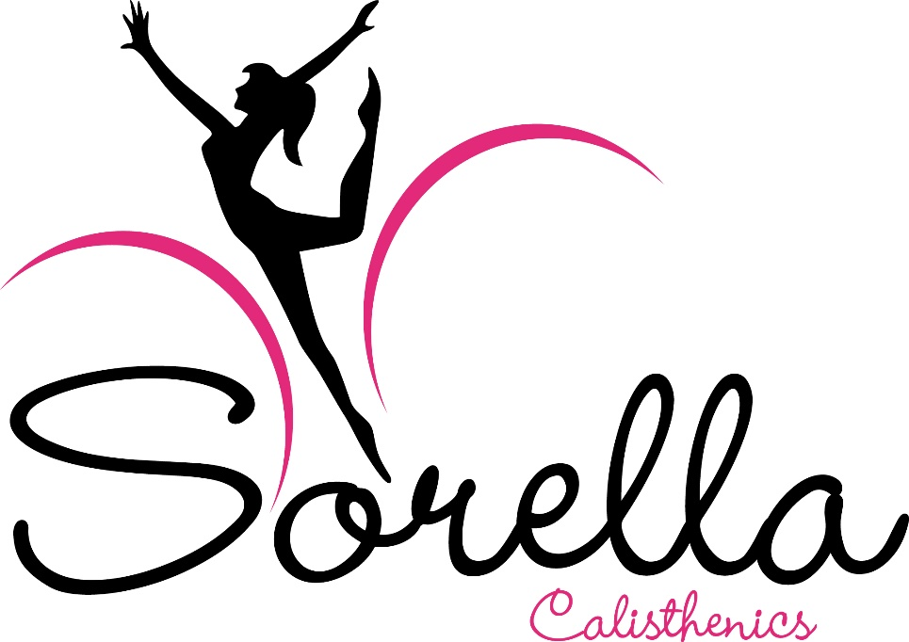

Child Safe Standards
CODE OF CONDUCT FOR DEALING WITH CHILDREN AND YOUNG PEOPLE
2022

Child Safe Standards
CODE OF CONDUCT FOR DEALING WITH CHILDREN & YOUNG PEOPLE

We want Children and Young People (CYP) in Calisthenics to feel safe, included, encouraged and supported – essentially, to enjoy themselves so that they keep participating. To make sure that we create this environment, Sorella Calisthenics Code of Conduct for Dealing with Children & Young People (Code of Conduct CYP) requires everyone involved in Calisthenics to abide by certain behavioural standards when it comes to dealing with Children & Young People (CYP). This table summarises those requirements. All behaviour towards CYP should consider the needs and safety of:
- indigenous CYP;
- CYP from culturally and linguistically diverse backgrounds; and
- CYP with a disability.

 | Code of Behaviour Requirement for dealing with Children & Young People
1 | Language and Tone of Voice:  - Should provide clear direction, encourage and affirm CYP and boost their confidence.  - Should NOT be harmful – i.e., derogatory (e.g. “you’re a loser), threatening, frightening, profane, discriminatory, racist, sexual.
2 | Adhering to professional role boundaries:  - Act only within the confines of your duties/role (e.g., if you’re a coach, just be a coach).  - Unless with express consent from a nominated Senior Person at Sorella Calisthenics do NOT:  - Provide unauthorised transportation to CYP  - Engage in activities or seek contact with CYP outside of Calisthenics.  - Involve yourself in CYP’s private and/or family matters, unless you reasonably believe or suspect that they are at risk of harm.  - Provide support to CYP or their families that is unrelated to Calisthenics.  - Accept an invitation to attend any private social function at the request of CYP or their family/carer in Calisthenics (current or past) unless there was an existing social, personal or family relationship.  If any of the above occur or you are made aware of a kid requiring assistance outside the confines of your role, either contact their parent/guardian or seek advice from an appropriate Senior Person in Sorella Calisthenics or at Calisthenics Victoria.

3 | Sending electronic communications to CYP (emails, texts and other direct messages):  - Must copy parent(s)/guardian(s) into any text, email, Facebook or any other form of electronic communication message.  - Must only communicate with CYP regarding issues relevant to Sorella Calisthenics  - Ensure that any messages are polite/friendly and in no way sexual in nature.  - Must not communicate with CYP, request to be “friends” or “follow” CYP using Internet chat rooms, social networking sites, game sites, instant messaging or anything of a similar nature, particularly to encourage social contact of an unauthorised nature.  - Must not request that CYP keep communication a secret.
4 | Supervision of CYP - When supervising CYP in Calisthenics:  - Avoid unsupervised situations with CYP wherever possible - you should always be in view of others.  - Engage positively with our sport.  - Behave appropriately towards one another.  - Ensure that you are in a safe environment, protected from external threats.
5 | Physical Contact with CYP – must be appropriate to delivery of Calisthenics (e.g, spotting in a walkover with explanation) and based on the needs of the CYP (i.e. to comfort if distressed). Unless for medical or allied health purposes by a health care professional, contact must not:  - Involve touching genitals, breasts or buttocks.  - Appear to have a sexual connotation.  - Be intended to cause pain or distress.  - Be overly physical (e.g., wrestling, tickling, etc).  - Be unnecessary (e.g., assisting CYP with toileting when they don’t need help).  - Be initiated against the wishes of CYP (unless to prevent injury, in which case physical restraint should be a last resort).  Physical contact initiated by CYP that is sexual and/or inappropriate behaviour between CYP must be reported to an appropriate Senior Person in Calisthenics in Victoria as soon as possible.
6 | Sexual Misconduct:  No form of “sexual behaviour” is to occur between, with or in the presence of CYP in Calisthenics, even if the CYP are above the legal age of consent – 16 years. This includes contact and non-contact behaviour (e.g. flirting, sexual innuendo, electronic messaging or photography).

7 | Positive Guidance and Discipline:  We want to create a positive environment for everyone in Sorella Calisthenics, understanding that CYP need to understand the acceptable limits of their behaviour, whilst ensuring that:  - We give CYP clear direction.  - CYP are given an opportunity to redirect their misbehaviour in a positive way.  - Behaviour management strategies are fair, respectful and appropriate to CYP’s developmental stage.  - No physical punishment, cruel/degrading/humiliating, etc treatment is used.  Under no circumstances is physical punishment to be used, nor any other treatment that could be considered as degrading, cruel, frightening, humiliating or discriminatory.
8 | Giving gifts to CYP: Must always be authorised by parents/guardians.
9 | Photographs/video footage of CYP:  - You may only take photographs or video footage of CYP involved in Sorella Calisthenics if:  - prior approval has granted by their parent(s)/guardian(s); and  - the context of the photo/footage is directly related to Sorella Calisthenics;  - CYP are appropriately dressed and posed; and  - the image/footage is taken in presence of others involved in Sorella Calisthenics  - Images must not be distributed to anyone outside Sorella Calisthenics other than CYPs (or parents/guardians) without knowledge and approval of a parent/guardian and nominated Senior Person in Sorella Calisthenics  - Images must not be exhibited online without parent/guardian approval unless CYP are de-identified
10 | Overnight Stays and Sleeping Arrangements for CYP:  Overnight stays are to only occur with the prior written authorisation of parents/guardians and the relevant Child Safe Officer of Sorella Calisthenics (or their nominated representative).
11 | Change Room arrangements: People involved in Sorella Calisthenics must:  - Supervise CYP in change rooms whilst balancing their right for privacy.  - Avoid one-to-one unsupervised situations with CYP in a change room area (other than with their own child), whilst ensuring adequate supervision to keep CYP safe (e.g., standing outside the entrance to the change room).  - Not dress/undress in the change room whilst CYP are present, unless they are playing in a Senior Team and there are other members of the team present.  - Ensure that photos, video or other recordings are not taken in change rooms. To manage this, consider a “NO MOBILE PHONES” policy and signage in change rooms.  - Ensure that participants use the change room of their affirmed gender.
12 | Use, possession or supply of alcohol or drugs:  - All persons involved in Sorella Calisthenics who are delivering a program or on overnight stays/camps involving CYP must not use possess or be under the influence of illegal or illicit drugs, alcohol or be incapacitated by any other legal drug.  - Legal (i.e., prescription) drugs are permitted to be used provided that it does not interfere with your ability to provide an appropriate level of care to CYP in Sorella Calisthenics and that you do not supply legal drugs (including alcohol and tobacco) to CYP.
13 | Transporting children:  - You can only transport CYP in circumstances that are directly related to the delivery of our sport and only with prior written approval of CYP’s parent/guardian and the express acknowledgment of a nominated Sorella Calisthenics Senior Person.  - If it is not possible to get prior written consent or approval, you must notify in writing the details of the travel to the nominated Senior Person at Sorella Calisthenics as soon as possible after the journey.  - Where it is not possible to get a parent/guardian’s approval in advance, the parent/guardian should send an approval text/electronic message to an appropriate Senior Person at Sorella Calisthenics. This should then be documented appropriately.
14 | Pick up and collection of CYP: We must:  - Ensure that CYP and their parents/guardians know the times/locations of training/matches and that they arrive before the scheduled times so that CYP aren’t unattended.  - Have an operational phone and register of parent/guardian emergency contact details.  - Ensure they are aware of pick up details for CYP and that all relevant approvals are given.  - If a parent/guardian is late, make efforts to contact them, noting that it is not your responsibility to drive CYP in Sorella Calisthenics home. You should also ask the second last child and their parent/guardian to wait until the final child is collected.  - Not leave the training session or match until all CYP have been collected.  - If necessary, ask the parent/guardian to collect their kid(s) from the club venue if there are others present and arrangements are documented.  - If a parent/guardian is repeatedly late to collect their kid(s), notify the nominated Senior Person at Sorella Calisthenics

