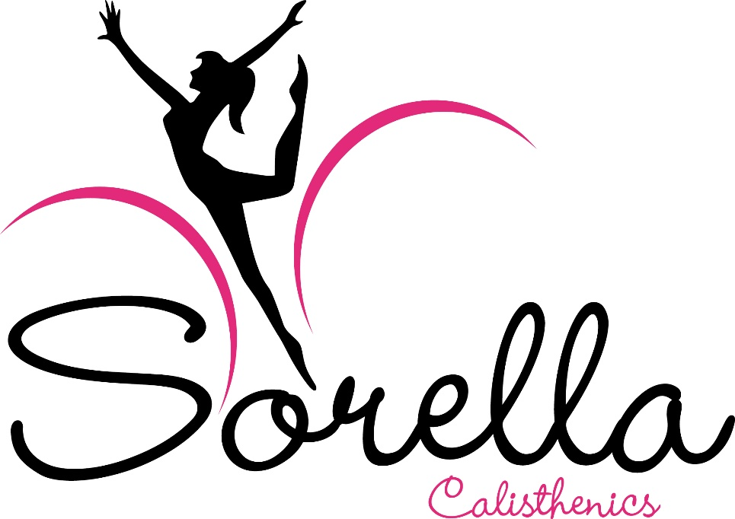

Child Safe Standards
SORELLA CALISTHENICS CHILD SAFE POLICY
2022:1

Sorella Calisthenics Inc
CHILD SAFE POLICY

- INTRODUCTION

  - Sorella Calisthenics is committed to ensuring that children and young people who participate in its activities have a safe and happy experience. Sorella Calisthenics supports and respects children, young people, coaches, volunteers and performers.

  - The aim of Sorella Calisthenics Child Safe Policy is to protect the safety of children in our care and prevent abuse from occurring, and in the event that allegations are raised in relation to child abuse, to ensure that the allegations are properly addressed. All complaints will be treated seriously and fully investigated and handled with maximum confidentiality and discretion.

  - Should a person wish to make any enquiries in relation to this Policy, please contact Samantha Holt – Co-Owner & Principal Coach 0421 424 079

- POLICY STATEMENT

  - Sorella Calisthenics is committed to providing the highest level of safety for all involved with Calisthenics. This includes protecting members' privacy, promoting positive behaviours and attitudes, protecting the health safety and wellbeing of members, particularly children and delivering Sorella Calisthenics’ activities while acting in the best interests of children in the sport.

  - Specifically, Sorella Calisthenics considers that the health, safety and well-being of children take priority over all other competing considerations. Sorella Calisthenics considers that this is necessary to ensure the health, safety and welfare of all members and protect the image and reputation of the sport, Sorella Calisthenics and its members.

  - Sorella Calisthenics has a zero-tolerance approach to child abuse and is committed to promoting and protecting children from abuse and neglect to the greatest extent possible. All children have equal rights to protection from child abuse, regardless of their sex, religion, disability or sexual orientation etc.

  - Child protection is a shared responsibility between Sorella Calisthenics, its employees, workers, contractors, associates, parents/guardians, coaches, spectators, volunteers and members of the Sorella Calisthenics community. Everyone that participates in Sorella Calisthenics activities is responsible for the care and protection of children, and reporting information about child abuse.

  - Sorella Calisthenics supports the active participation of all children. It listens to their views, respects their views and involves them when making decisions, where appropriate, especially about matters that will directly affect them (including their safety). Some of the ways in which Sorella Calisthenics empowers children are:
- Regular individual Health & Wellbeing Check-Ins
- Formal & Informal Surveys

  - Sorella Calisthenics is also committed to the cultural safety of Aboriginal children, and those from culturally and/or linguistically diverse backgrounds, and to providing a safe environment for children living with a disability.

  - Sorella Calisthenics promotes fairness and consideration for all staff, volunteers and participants. For further details please refer to the Sorella Calisthenics Member Protection Policy.

- SCOPE

  - This Policy applies to everyone involved in or connected to Calisthenics, including (but not limited to) performers, parents, spectators, contractors, officials, coaches, judges and staff throughout all Sorella Calisthenics events and activities.

  - This Policy will continue to apply retrospectively to a person or Member following the cessation of their association or employment with Sorella Calisthenics.

- RELATED DOCUMENTS & LEGISLATIVE REQUIREMENTS

  - This Policy must be read in conjunction with:

    - the laws of the Commonwealth and Victoria (as amended from time to time) including but not limited to:

      - Children, Youth and Families Act 2005 (Vic)

      - Child Wellbeing and Safety Amendment (Child Safe Standards) Act 2015 (Vic)

      - Crimes Act 1958 (Vic); and

      - Working with Children Act 2005 (Vic)

    - Sorella Calisthenics policies and procedures, including but not limited to:

      - Privacy Policy;

      - Social Media Policy

      - Child Safe Policy

      - Member Protection Policy;

      - Communication Policy

      - Code of Conduct

- DEFINITIONS

  - Child means a person involved in the activities of Sorella Calisthenics (including athletes) and under the age of 18 years unless otherwise stated under the law applicable to the child (eg, for the purposes of child sexual offences in Victoria, a “child” refers to a person under the age of 16 years).

  - Child Abuse is the mistreatment of a Child or Young Person that has Harmed, is Harming or is likely to Harm or endanger that Child or Young Person’s physical or emotional health, development or wellbeing and the Child has not, or is not likely to be protected by the parent(s) or guardian(s). For the avoidance of doubt, this includes but is not limited to Emotional or Psychological Abuse, Bullying, Grooming, Sexual Exploitation, Neglect and Harassment.

  - Child protection means any responsibility, measure or activity undertaken to safeguard children from Harm.

  - Grooming is a term used to describe what happens when a perpetrator of Abuse builds a relationship with a Child with a view to abusing them at some stage. There is no set pattern in relation to the Grooming of Children. For some perpetrators, there will be a lengthy period of time before the Abuse begins. The Child may be given special attention and what starts as an apparently normal display of affection, such as cuddling, can develop into sexual touching or masturbation and then into more serious sexual behaviour. Other perpetrators may draw a Child in and Abuse them relatively quickly. Some abusers do not groom Children but Abuse them without forming a relationship at all. Grooming can take place in any setting where a relationship is formed, such as leisure, music, sports and religious activities, or in internet chatrooms, in social media or by other technological channels.

  - Harm means Harm to a person or a Child is any detrimental effect of a significant nature to the person or Child’s physical, psychological or emotional wellbeing. It is immaterial how the harm is caused. Harm can be caused by:
- Physical, Psychological or Emotional Abuse or Neglect;
- Sexual Abuse or Exploitation;
- a single act, omission or circumstance; and
- a series or combination of acts, omissions or circumstances.

  - Sexual offence (in Victoria) means a criminal offence involving sexual activity or actions of indecency or any act which exposes a child under the age of 16 years to, or involves a child under the age of 16 years in, sexual activity or matters beyond his or her understanding or contrary to accepted community standards. Sexually offence behaviours can include the fondling of genitals, masturbation, oral sex, vaginal or anal penetration by a penis, finger or any other object, fondling of breasts, voyeurism, exhibitionism, and exposing the child to or involving the child in pornography. It includes grooming, which includes actions deliberately undertaken with the aim of befriending and establishing an emotional connection with a child under the age of 16 years (or their carer, family or supervisor) to lower their inhibitions and prepare them for engagement in a sexual offence.

  - Mandatory reporter means a person who is legally required to make a report to the Department of Health and Human Services or the Police if they form a belief on reasonable grounds that a child is in need of protection. It includes (but is not limited to) teachers, principals, registered psychologists, nurses, doctors and midwives.

- RECOGNISING AND REPORTING CHILD ABUSE

  - A person may, in the course of participating in the sport or other activities of Sorella Calisthenics or carrying out their work, form a belief on reasonable grounds that a child is in need of protection from child abuse.

  - If a person is concerned about an immediate risk to a child’s safety, the person must phone Victoria Police on “000” as soon as practicable.

  - Specific types of Child abuse include:

    - Physical abuse: occurs when a child has suffered, or is likely to suffer, significant Harm as a result of a physical injury, such as a non-accidental physical injury.

    - Sexual abuse: occurs when a child has suffered, or is likely to suffer, significant Harm as a result of sexual abuse, such as when a child is exploited, or used by another for his or her sexual gratification or sexual arousal, or for that of others.

    - Emotional and psychological abuse: occurs when a child has suffered, or is likely to suffer, emotional or psychological Harm of such a kind that the child’s emotional or intellectual development is or is likely to be significantly damaged; and

    - Neglect: occurs when a child’s physical development or health has been,or is likely to be significantly damaged. It refers to an omission, such as depriving a child of food, clothing, warmth, hygiene, intellectual stimulation, supervision and safety, attachment to and affection from adults, or medical care.

  - Mandatory Reporters

    - Select classes of people in the community (including teachers, nurses and doctors – amongst others) are required by law to report to the Child Protection Unit of the Department of Health and Human Services (DHHS) where they have formed a belief, on reasonable grounds, that a child is in need of protection because they have suffered (or are likely to suffer) significant harm due to physical or sexual abuse.

    - This report must be made as soon as practicable, and after each occasion where he or she becomes aware of a further reasonable grounds for the belief.

  - Reasonable grounds for belief

    - A reasonable belief is formed if a reasonable person believes that:

      - the child is in need of protection;

      - the child has suffered or is likely to suffer significant harm as a result of physical or sexual injury; and

      - the child’s parents are unable or unwilling to protect the child.

    - To form a reasonable belief, you should consider and objectively assess all the relevant facts, such as the source of the allegation and how it was communicated, the nature of and details of the allegation, and whether there is any other related matters known regarding the alleged perpetrator.

    - A ‘reasonable belief’ or a ‘belief on reasonable grounds’ is not the same as having proof, but is more than mere rumour or speculation.

    - You will have reasonable grounds to notify if:

      - a child states that they have been physically or sexually abused;

      - a child states that they know someone who has been physically or sexually abused (sometimes the child may be talking about themselves);

      - someone who knows a child states that the child has been physically or sexually abused;

      - professional observations of the child’s behaviour or development leads a professional to form a belief that the child has been physically or sexually abused or is likely to be abused; or

      - signs of abuse lead to a belief that the child has been physically or sexually abused.

  - Voluntary Reporters

    - In addition to the mandatory reporting obligations above, any person who believes on reasonable grounds that a child is in need of protection from any form of child abuse, may disclose that information to the Police, DHHS or the Commissioner for Children & Young People (CCYP).

  - Reporting Child Sexual Abuse

    - If a person receives information that leads them to form a reasonable belief that a sexual offence has been committed in Victoria against a child (under the age of 16 years) by another person (of or over the age of 18 years), the person has a legal obligation to disclose that information to the Police as soon as it is practicable. Individuals who fail to comply with this obligation under the Crimes Act 1958 (Vic) may be subject to a penalty of imprisonment.

  - Sorella Calisthenics Approach to Reports of Abuse

    - Sorella Calisthenics supports and encourages a person to make a report to the Police, CCYP or DHHS if they form a belief on reasonable grounds that a child is in need of protection, or they are concerned about the safety, health or wellbeing of a child.

    - Any person that makes a report in good faith in accordance with their reporting obligations (whether mandatory or voluntary) will be supported by Sorella Calisthenics, and will not be penalised by Sorella Calisthenics for making the report.

    - If a person is uncertain as to whether they should make a report to an external authority in relation to the safety of a child, they may speak to the Sorella Calisthenics President or Sorella Calisthenics MPIO for guidance and information. If in doubt, ask for assistance.

    - If an allegation is made against a member of staff or volunteer, Sorella Calisthenics will follow the reporting procedure outlined in Sorella Calisthenics Child Safe Policy and take all steps to ensure that the safety of the child and other children is paramount..

    - Sorella Calisthenics will investigate allegations of inappropriate conduct against a child in accordance with procedural fairness and will handle the allegations in a confidential and sensitive manner to the greatest extent possible.

    - Sorella Calisthenics will cooperate with the directions of the Police, CCYP and/or DHHS in relation to any investigation conducted by these authorities.

    - Sorella Calisthenics will keep a register of any allegations regarding inappropriate conduct.

- ROLES AND RESPONSIBILITIES OF PERSONNEL PROTECTING CHILDREN
  - Personnel involved in protecting children include the board, management, staff and volunteers within the Organisation. Those people have responsibilities in relation to protection of children and are expected to:
    - understand the rights of children, as appropriate to their role;

    - respect the cultural and religious practices of families who access Sorella Calisthenic's services, programs or events;

    - understand and appropriately respond to the needs of children with developmental delays or disabilities;

    - appropriately act on any concerns raised by children;

    - understand the definitions, indicators and impact of child abuse;

    - at all times, know and follow regulations in relation to the care of children and follow the Code of Conduct & Child Safe Policy

    - co-operate with police and/or other formal investigations to the best of their ability; and

    - not harm or exploit children who access Sorella Calisthenics's services.

  - Sorella Calisthenics will appoint a Child Safety Officer or equivalent role that will be the primary point of contact for all concerns related to child safety.

- RECRUITMENT AND SCREENING

  - The minimum standard for background checks of employees, contractors and volunteers of Sorella Calisthenics and its members is the law as it applies in Victoria.

  - Sorella Calisthenics undertakes a comprehensive recruitment and screening process for all staff, contractors and volunteers which aims to:

    - Promote and protect the safety of all children who participate in the activities of Sorella Calisthenics

    - Identify and recruit the safest and most suitable candidates who share Sorella Calisthenics’s values and commitment to protect children; and

    - Prevent a person from working at Sorella Calisthenics if they pose an unacceptable risk to children.

  - Sorella Calisthenics requires staff, contractors and volunteers to pass the recruitment and screening process prior to commencing their engagement with Sorella Calisthenics

  - As part of the screening and recruitment process, an applicant must provide appropriate evidence (e.g. WWCC or other state equivalent and/or Police check) to show that they are suitable to work with children and young people in a recreational setting. Sorella Calisthenics requires that:

    - All Sorella Calisthenics staff and Board members require a WWCC; and

    - the following key event personnel must have a valid WWCC:

      - Those paid by Sorella Calisthenics for their services (excluding bump in and bump out);

      - Volunteers with regular roles in Sorella Calisthenics

      - Relevant contractors who may have unsupervised access to children; and

      - Anyone else who Sorella Calisthenics staff feel requires a WWCC due to the nature of the work that they are undertaking for Sorella Calisthenics

  - The type of evidence that an applicant is required to provide to Sorella Calisthenics will vary depending on the type of position that they are applying for. However, an applicant will not be offered a position until they provide the required evidence to Sorella Calisthenics

  - Sorella Calisthenics will exercise discretion and may require applicants to provide a Police check in accordance with the law and as appropriate, before they commence their engagement and during their time with Sorella Calisthenics in regular intervals.

  - Sorella Calisthenics will undertake at least two thorough reference checks prior to engaging any personnel.

  - Once engaged, Sorella Calisthenics will provide staff and volunteers with access to this policy and staff and volunteers must review and acknowledge their understanding of this policy.

  - Sorella Calisthenics requires all affiliated club personnel including owners, Committee Members, Volunteers, Coaches and Judges and anyone else who has contact with children to possess a valid working with children check. Any costs associated with gaining a valid WWCC will be dealt with in a manner determined by that club.

- SUPPORTING PERSONNEL

  - Sorella Calisthenics is committed to ensuring that all staff, Board members, volunteers and contractors receive training to ensure that they understand their responsibilities in relation to child safety.

  - Mandatory training at Sorella Calisthenics includes:

    - Play by the Rules Training
    - Sport Integrity Australia Child Safeguarding in Sport Induction

  - Sorella Calisthenics assists its Board members, staff, contractors and volunteers to incorporate child safety considerations into decision-making and to promote a culturally safe environment where children are empowered to speak up about issues that affect them.

- RISK MANAGEMENT APPROACH

  - Child safety is a part of Sport Integrity Australia Child Safeguarding in Sport Induction 's overall risk management approach.

  - See CCYP Guide for Creating a Child Safe Organisation.

- POLICY BREACHES

  - It is a breach of this policy for any person or organisation to which this policy applies, to have been found to have done anything contrary to this policy. Any person who may breach this policy is subject to (insert relevant organisation discipline process, Member Protection Policy and/or grievance procedure outlined in the organisation constitution).

- POLICY PROMOTION
  - This policy will be made available to all members via our website and email

  - This policy will be communicated to all staff, Board, and Committee members via email

  - References to this policy will be included in documentation provided to all team officials that represent Sorella Calisthenics

- RECORD KEEPING

  - Sorella Calisthenics will retain records of reports of child abuse and complaints about child safety.

  - In maintaining records of reports about child safety, Sorella Calisthenics will maintain confidentiality and privacy for children and families in accordance with legislation.

  - Sorella Calisthenics will appropriately note identified risks to child safety through the record keeping process and will incorporate those into its risk management plan.

- REVIEW PROCESS
  - This policy will be reviewed by the Sorella Calisthenics Board on a biennial basis.

  - If you would like to provide Sorella Calisthenics with any feedback or suggestions to improve this policy, please contact Samantha Holt 0421 424 079 or sorellacc@hotmail.com

  - In addition to the regular review of this policy, recommendations for changes to the policy may be submitted to the Board for consideration at any time. In the event that changes are accepted, the policy will be updated, and circulated to all stakeholders via the webpage, bulletin and other appropriate communication channels.

